29 June 2007 The Weekly Bulletin of Rotary Club of Kathmandu Mid-Town Bc # 52 of 2006-07
Rotary Club of Kathmandu Mid-Town
Breakfast Chatter




District : 3290 Web: www.rotarymidtown.org.np Club Id : 26776

JUNE IS THE FELLOWSHIP MONTH
Rotary Fellowships . . .
. . . The Friend Makers !
Clubs and districts are encouraged to promote Fellowships, especially during the month of June, Rotary Fellowships Month. Governors are encouraged to promote Fellowship activities in monthly letters and to report at the district assembly or district conference on progress in Fellowship activities for the year. Fellowships are encouraged to hold recognition days to increase interest in their activities, and in Rotary in general. Each Fellowship is encouraged to maintain a website to promote and inform its membership.

Joint Board Meeting :
Joint Board meeting of 2006-07 and 2007-08 teams was held at President CK Golchha's residence at Sitapaila on Saturday, 19 June 2007 evening. Besides the Board members and their spouses, all Mid-Towners with their spouses were invited to the dinner that followed the joint Board meeting.
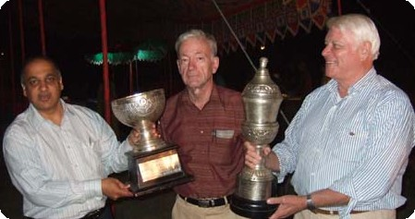
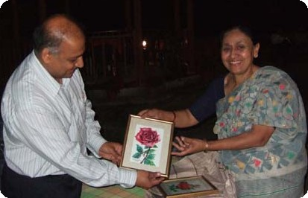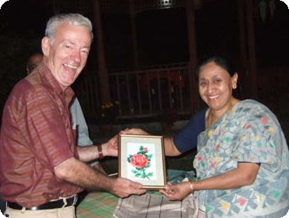
a) President CK Golchha handing over the Running Trophies awarded to the Club at District Awards Ceremony recently for being the Best Club in Community Service and International Service Avenues
to the new 2007-08 Board .
b) and c) Sharada Chitracar, spouse of IPP Komal Chitracar handing over her painting souvenir to out-going president CK Golchha and in-coming president Walter Diller.

Weekly Meetings and Programs :
Date | Program/Speaker | Program/Topics of Presentation
29 June 2007 | Club Assembly | Club Assembly

Friday, 29 June :
The scheduled Club assembly on 22 June 2007 could not be held for technical reason: PE Walter Diller could not attend the meeting; therefore, the meeting decided to postpone Club assembly until next week.
Club assembly: President-Elect Walter Diller and his team will provide highlights of their plans and programs for the Rotary Year 2007-08.

District Awards 2007 (Cont'd) :
Awards In Appreciation of Contribution Towards Making Rotary Year 2006/2007 Successful
1. Dilendra Raj Shrestha, Chief Coordinator 2.Mani Dhoj Joshi, District Trainer
3. Gopal S. L. Kakshapati, District Secretary 4.Siba Bhakta Rajbhandari, District Treasurer
5. William Ma, District Rotary Foundation Coordinator 6.Ram Prasad Joshi, District P R Coordinator
7. Hari Om Shrestha, District Grant Coordinator 8.Ratna Man Shakya, District M'ship Coordinator
9. Maheswor Bhakta Shrestha, District Editor 10.Ranjan Kuthari, Chief Coordinator
11. Chintamani Bhattarai, Regional Coordinator 12.Pushkar Man Shakya, Regional Coordinator
13. Kamal Dahal, Assistant Governor 14.Rajendra Bahadur Shrestha, Assistant Governor
15. Rajesh Thapa, Assistant Governor 16.Dr. Chandra Lekha Tuladhar, Asst Governor
17. Matsendra Lal Kayastha, Assistant Governor 18.Dr. Madan Kumar Piya, Assistant Governor
19. Rabindra Kumar Piya, Regional Coordinator 20. Madan Lal Joshi, Assistant Governor
21. Beni Gopal Mundara, Regional Coordinator 22.Krishna Kumar Agrawal, Assistant Governor
23. Vinod Chandra Varal, Regional Coordinator 24.Dhruba Tulachan, Assistant Governor
25. Jagan Bahadur Gurung, Assistant Governor 26.Dr. Biswa Keshar Maskey, District Com. Chair
27. Dr. Nastu Sharma, District Committee Co-Chair 28.Gyanu Raj Shakya, District Committee Chair
29. Iswar Man Pradhan, District Committee Chair 30.Surendra Dhakal, District Committee Chair
31. Biso Bajracharya, District Committee Chair 32. Ajaya Sthapit, District Committee Chair
33. Santosh Sharma, District Committee Chair
Best Club in Club Service : Rotary Club of Yala
Best Club in Vocational Service : Rotary Club of Yala
Best Club in Community Service : Rotary Club of Kathmandu Midtown
Best Club in International Service : Rotary Club of Kathmandu Midtown
BEST CLUB OF THE YEAR : Rotary Club of Yala

On Lighter Side : Click at the figure ⇩


It has been a great joy this year to see how Rotarians all over the world are choosing to Lead the Way. I look forward to continuing with you in this great task for many more years to come. Lorna and I thank you for your many kindnesses to us. This year has changed our lives.
RI President William B. Boyd

Editor's Note : This is the 52nd issue of Breakfast Chatter, the Club Bulletin, of the Year 2006-07. And, of course, the last one from RR Shrestha as the Club Service Director. Fifty-two weeks are gone by, so fast! It is true that the BCs did not meet every Mid-Towner's expectation. There were limitations. The editor would like to express his gratitude to all Mid-Towners for their comments, criticisms, and encouragement during the year which were quite inspiring and boosted up the editor's morale. He takes on responsibility for any lapses in the BCs. This is not the end of BC itself, rather only end of 2006-07 editorial team's term. The BCs will, of course, continue coming to you, from the new editorial team. Thank you all !

29 June 2007 The Weekly Bulletin of Rotary Club of Kathmandu Mid-Town Bc # 52 of 2006-07

Editor: RR Shrestha, Club Service Director email: rryes@wlink.com.np

